Program Needs

Unity 2017.4.33f1 (LTS) with

MonoDevelop/Unity Debugger

Documentation

Standard Assets

Android Build Support

Windows Store .NET Scripting

Windows Store IL2CPP Scripting

Vuforia Augmented Reality

WebGL Build Support

Demo Location

GitHub – TstackingCapstone – Spatial Demo

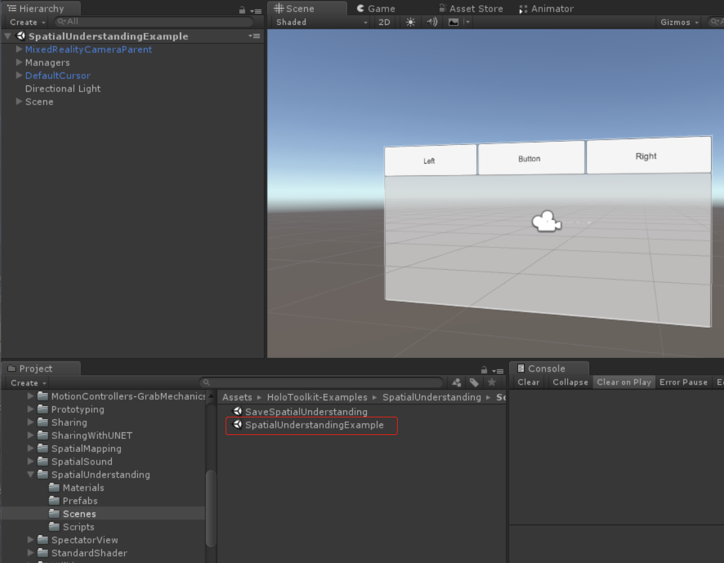

Capstone Idea

1. Showing the "T"
2. Using spatial understanding from HoloTookit and algorithm calculate the box position
3. Using Vuforia ground plane detection and algorithm calculate the box position

Tasks:

1. Understanding or even edit the code in spatial understanding Demo from Microsoft. The main goal is to generate the plane base on the container(such as empty table)
2. Researching Vuforia ground plane detection. The main goal is to generate the plane base on the container(such as empty table)
3. In the future, when we can get the width and length of the plane, research the algorithm to calculate the position.
4. QR Code to store and retrieve the information of boxes.